**What is Elastic Compute Cloud (EC2)?**

EC2 stands for Elastic Compute Cloud. EC2 is an on-demand computing service on the AWS cloud platform. Under computing, it includes all the services a computing device can offer to you along with the flexibility of a virtual environment. It also allows the user to configure their instances as per their requirements i.e. allocate the RAM, ROM, and storage according to the need of the current task. Even the user can dismantle the virtual device once its task is completed and it is no more required. For providing, all these scalable resources AWS charges some bill amount at the end of every month, the bill amount is entirely dependent on your usage. EC2 allows you to rent virtual computers. The provision of servers on AWS Cloud is one of the easiest ways in EC2. EC2 has resizable capacity. EC2 offers security, reliability, high performance, and cost-effective infrastructure so as to meet the demanding business needs.

**AWS EC2 (Elastic Compute Cloud)**

[Amazon Web Service](https://www.geeksforgeeks.org/aws-tutorial/) EC2 is a web service which is provided by the AWS cloud which is secure, resizable, and scalable. These virtual machines are pre-configured with the operating systems and some of the required software. Instead of managing the infrastructure AWS will do that so you can just launch and terminate the EC2 instance whenever you want. You can scale up and down the [EC2 instance](https://www.geeksforgeeks.org/create-an-ec2-instance-with-ec2-user-data-script-to-launch-website/) depending on the incoming traffic. The other advantage of AWS EC2 is that you need to pay only for how much you use it is like the pay-as-you-go model.

**What is Amazon EC2 (Elastic Compute Cloud)?**

[Amazon Web service](https://www.geeksforgeeks.org/introduction-to-amazon-web-services/) offers EC2 which is a short form of Elastic Compute Cloud (ECC) it is a cloud computing service offered by the Cloud Service Provider AWS. You can deploy your applications in EC2 servers without any worrying about the underlying infrastructure. You configure the EC2-Instance in a very secure manner by using the VPC, [Subnets,](https://www.geeksforgeeks.org/amazon-vpc-introduction-to-amazon-virtual-cloud/)and [Security groups.](https://www.geeksforgeeks.org/what-is-security-group-in-aws-and-how-to-create-it/) You can scale the configuration of the EC2 instance you have configured based on the demand of the application by attaching the autoscaling group to the EC2 instance. You can scale up and scale down the instance based on the incoming traffic of the application.

The following figure shows the EC2-Instance which is deployed in[VPC (Virtual Private Cloud).](https://www.geeksforgeeks.org/amazon-vpc-introduction-to-amazon-virtual-cloud/)

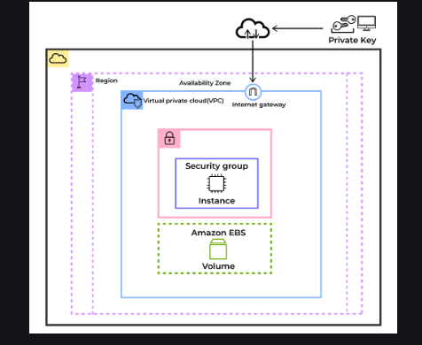

**Use Cases of Amazon EC2 (Elastic Compute Cloud)**

The following are the use cases of Amazon EC2:

1. **Deploying Application:** In the [AWS](https://www.geeksforgeeks.org/aws-tutorial/) EC2 instance, you can deploy your application like **.jar,.war,** or **.ear** application without maintaining the underlying infrastructure.
2. **Scaling Application:**Once you deployed your web application in the EC2 instance know you can scale your application based upon the demand you are having by scaling the AWS EC2-Instance.
3. **Deploying The ML Models:**You can train and deploy your[ML](https://www.geeksforgeeks.org/machine-learning/)models in the EC2-instance because it offers up to 400 Gbps), and storage services purpose-built to optimize the price performance for ML projects.
4. **Hybrid Cloud Environment:**You can deploy your web application in EC2-Instance and you can connect to the database which is deployed in the on-premises servers.
5. **Cost-Effective:**Amazon EC2-instance is cost-effective so you can deploy your gaming application in the Amazon EC2-Instances

**Features of AWS EC2 (Elastic Compute Cloud)**

The following are the features of AWS EC2:

**1. AWS EC2 Functionality**

EC2 provides its users with a true virtual computing platform, where they can use various operations and even launch another EC2 instance from this virtually created environment. This will increase the security of the virtual devices. Not only creating but also EC2 allows us to customize our environment as per our requirements, at any point of time during the life span of the virtual machine. Amazon EC2 itself comes with a set of default AMI(Amazon Machine Image) options supporting various operating systems along with some pre-configured resources like RAM, ROM, storage, etc. Besides these AMI options, we can also create an AMI curated with a combination of default and user-defined configurations. And for future purposes, we can store this user-defined AMI, so that next time, the user won’t have to re-configure a new [AMI(Amazon Machine Image)](https://www.geeksforgeeks.org/what-is-amazon-machine-image-ami/)from scratch. Rather than this whole process, the user can simply use the older reference while creating a new EC2 machine.

**2. AWS EC2 Operating Systems**

Amazon EC2 includes a wide range of operating systems to choose from while selecting your AMI. Not only are these selected options, but users are also even given the privilege to upload their own operating systems and opt for that while selecting AMI during launching an EC2 instance. Currently, AWS has the following most preferred set of operating systems available on the EC2 console.

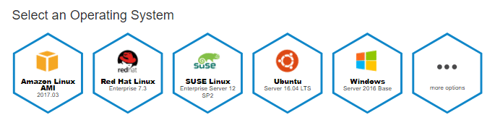

* [Amazon Linux](https://www.geeksforgeeks.org/how-to-connect-to-amazon-linux-instance-from-windows-client-operating-system-using-putty/)
* Windows Server
* Ubuntu Server
* SUSE Linux
* Red Hat Linux

**3. AWS EC2 Software**

Amazon is single-handedly ruling the cloud computing market, because of the variety of options available on EC2 for its users. It allows its users to choose from various software present to run on their EC2 machines. This whole service is allocated to AWS Marketplace on the AWS platform. Numerous software like SAP, LAMP, Drupal, etc are available on AWS to use.

**4. AWS EC2 Scalability and Reliability**

EC2 provides us the facility to scale up or scale down as per the needs. All dynamic scenarios can be easily tackled by EC2 with the help of this feature. And because of the flexibility of volumes and snapshots, it is highly reliable for its users. Due to the scalable nature of the machine, many organizations like Flipkart, and Amazon rely on these days whenever humongous traffic occurs on their portals.

**Benefits of Amazon EC2**

The following are the benefits of Amazon EC2:

* **Scalability:**It helps to easily scale the instances up or down based on the demand with ensuring the optimal performance and cost-efficiency.
* **Flexibility:** It provides wide variety of instance types and configurations for matching different workload requirements and operating systems.
* **Cost-Effectiveness:** It comes with providing Pay-as-you-go model with options like On-Demand, Reserved, and Spot Instances for managing cost efficiently.
* **High Availability and Reliability**: It offers multiple geographic regions and availability zones for strong fault tolerance and disaster recovery.

**Introduction to Google Compute Engine**

Google Cloud Platform offered by Google is a suite of Cloud Computing Services that runs on the same infrastructure that Google uses internally for its end-user products such as Google Search, Gmail, File storage, and YouTube.  Along with the set of management tools, it also provides a series of modular cloud services including

* [Computing](https://www.geeksforgeeks.org/cloud-computing/)
* [Data Storage](https://www.geeksforgeeks.org/google-cloud-platform-cloud-storage/)
* [Data Analytics](https://www.geeksforgeeks.org/data-analytics-and-its-type/)
* [Machine Learning](https://www.geeksforgeeks.org/machine-learning/)

**What is Google Compute Engine?**

**Google Compute Engine**is an IaaS component of Google Cloud Platform (GCP). It is built on the global infrastructure that runs[Google’s  Search Engine](https://www.geeksforgeeks.org/search-engines-work/), [Gmail](https://www.geeksforgeeks.org/what-is-an-email/), YouTube, and other Big Services.  Google’s Compute Engine is a part of the computer platform Google service component of Google Cloud Platform which is built on the global infrastructure that runs Google’s Search Engine, YouTube, and Other Services.

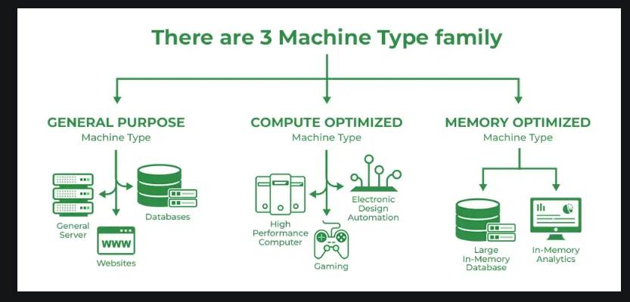

**GCE**is part of Compute Platform in Google Cloud.  Google Compute Engine offers [Virtual Machines](https://www.geeksforgeeks.org/virtual-machines-in-operating-system/) running in Google data centers connected to worldwide fiber networks. The tooling and workflow offered by the compute engine enable serving from single instances to global ones. It enables users to launch Virtual Machines on-demand  VMs can be launched from the standard images or custom images created by users. The GCE users must authenticate based on 2.0 before launching the Virtual Machine. Auth 2.0 is here the Open Standard for access delegation commonly used as a way for internet users to brand websites or applications access to their information on other websites but without giving them the passwords.

**Applications of Google Compute Engine**

Google Compute Engine will allow you to run your application and services on virtual machines. Below are some common applications of Google Compute Engine.

1. **Web applications hosting:**Google compute engine will provide the storage, and networking resources to host your [web application](https://www.geeksforgeeks.org/servlet-web-application/).
2. **Can run large-scale data:**Google compute engine is suitable for data analysis, and scientific simulations which need to handle large-scale data.
3. **Gaming servers:** Google’s compute engine has low latency so it is very suitable to host multiple gaming infrastructures.
4. **Support Docker and Kubernetes:**Google compute engine will support [containerization applications](https://www.geeksforgeeks.org/containerization-using-docker/). Either you can run containers as a single or you can maintain the clusters which are provided by Kubernetes and [docker-compose](https://www.geeksforgeeks.org/docker-compose/).

**Features of Google Compute Engine**

* **Machine Type:-**It describes Virtual hardware attached to an instance, it also includes [RAM](https://www.geeksforgeeks.org/random-access-memory-ram/)and [CPU](https://www.geeksforgeeks.org/central-processing-unit-cpu/). It can further have two types:
* **Local SSD:**GCE always offers encrypted local solid-state drive block storage which is physically attached to the Virtual Machine running it. It improves performance and also reduces latency.
* **Persistent Disk:**Durable high-performance block storage for VM instances that can be created in Hard Disk and SSD formats, so users can take snapshots and create a new persistent disk from the snapshots.
* **GPU Accelerators:** GPUs are added to accelerate workloads like Machine Learning or virtual workstation applications etc.
* **Image:**An image contains the Operating system of the root file that uses leverage to run a virtual machine instance.
* Global Load Balancing: helps in distributing requests across pools of instances across multiple regions.
* Other features include Linux and Windows Support containers, Reservation, OS patch management live migration for Virtual machines, and many more.

**Why Do Organizations Prefer Google Compute Engine?**

The following are the reasons that the Google compute engine is mostly used in organizations:

1. **Scalability:** Scaling up and down based on traffic will be done automatically by Google Compute Engine. Because of automation, the cost will be reduced there is a need to maintain every time maximum servers will scale up automatically based on the incoming traffic.
2. **Security:** For any organization, security is the most important thing to secure their data Google Compute Engine offers a wide variety of features like encryption of data and controlling the authorization and authentication of the users to the Google Cloud Resources.
3. **Cost-effectiveness:**Billing will be based on the resource used per certain time like it is pay as you go model.
4. **Integrations:** You can integrate with different services which are available in google cloud like kubernetes and the storages. It can manage different workloads based on the incoming traffic**.**

**Advantages of Google Compute Engine**

1. **Scalability:** Google compute engines helps us to scale up or down our VMs automatically based on incoming traffic to meet the changing demands.
2. **Load balancing:** We can increase the performance of an application by distributing traffic to several regions and availability zones with the aid of the Google compute engine load balancing.
3. **Security:** You can protect data which is stored in GCP by applying encryptions, restricting access to the users, and restricting the incoming traffic to our application.
4. **Integration:** You can integrate with different services which are available in google cloud like kubernetes and storage. It can manage different workloads based on the incoming traffic.
5. **Operating systems:**It can support no.of operating systems like RedHat, Ubuntu Windows servers, and so on.

**Google Compute Engine Pricing**

Flexible pricing is offered by Google Compute Engine (GCE). As mentioned below:

1. **Pay-as-you-go:**We can pay only for the resources that we use on an hourly basis.
2. **Committed Use Discounts (CUD):**Committed Use Discounts (CUD) are like the organization giving commitment to the Google Cloud by saying we will use certain resources for certain years. Then Google Cloud will provide a discount on that particular resource.
3. **Sustained Use Discounts (SUD):**With SUD, as your usage increases over time, you automatically enjoy reductions on your usage. SUDs are the best choice for workloads that operate constantly for a long time.

What is the IBM Cloud

The IBM Cloud® platform combines platform as a service (PaaS) with infrastructure as a service (IaaS) to provide an integrated experience. The platform scales and supports both small development teams and organizations, and large enterprise businesses. Globally deployed across data centers around the world, the solution you build on IBM Cloud® spins up fast and performs reliably in a tested and supported environment you can trust!

IBM Cloud provides solutions that enable higher levels of compliance, security, and management, with proven architecture patterns and methods for rapid delivery for running mission-critical workloads. Available in data centers worldwide, with multizone regions in North and South America, Europe, Asia, and Australia, you are enabled to deploy locally with global scalability.

IBM Cloud offers the most open and secure public cloud for business with a next-generation hybrid cloud platform, advanced data and AI capabilities, and deep enterprise expertise across 20 industries. Solutions are available depending on your needs for working in the public cloud, on-premises, or a combination:

* With public cloud, the resources are made available to you over the public internet. It is a multi-tenant environment, and resources like hardware and infrastructure are managed by IBM®.
* A [hybrid cloud solution](https://www.ibm.com/hybrid-cloud) is a combination of public and private giving you the flexibility to move workloads between the two based on your business and technological needs. IBM uses Red Hat OpenShift on IBM Cloud, the market-leading hybrid cloud container platform for hybrid solutions that enables you to build once and deploy anywhere. With IBM Cloud Satellite, you can create a hybrid environment that brings the scalability and on-demand flexibility of public cloud services to the applications and data that runs in your secure private cloud.
* Support for [multicloud](https://www.ibm.com/topics/multicloud" \t "_blank) and hybrid multicloud solutions is also available, which makes it easy for you to work with different vendors. [IBM Cloud Paks](https://www.ibm.com/cloud-paks) are software products for hybrid clouds that enable you to develop apps once and deploy them anywhere.
* [Virtual Private Cloud (VPC)](https://cloud.ibm.com/docs/vpc?topic=vpc-getting-started) is available as a public cloud service that lets you establish your own private cloud-like computing environment on shared public cloud infrastructure. With VPC, enterprises can define and control a virtual network that is logically isolated from all other public cloud tenants, creating a private, secure place on the public cloud.

With our open source technologies, such as Kubernetes, Red Hat OpenShift, and a full range of compute options, including virtual machines, containers, bare metal, and serverless, you have the control and flexibility that's required to support workloads in your hybrid environment. You can deploy cloud-native apps while also ensuring workload portability.

Whether you need to migrate apps to the cloud, modernize your existing apps by using cloud services, ensure data resiliency against regional failure, or use new paradigms and deployment topologies to innovate and build your cloud-native apps, the platform's open architecture is built to accommodate your use case.

**What's built into the platform?**

As the following diagram illustrates, the IBM Cloud platform is composed of multiple components that work together to provide a consistent and dependable cloud experience.

* A robust console that serves as the front end for creating, viewing, managing your cloud resources
* An identity and access management component that securely authenticates users for both platform services and controls access to resources consistently across IBM Cloud
* A catalog that consists of hundreds of supported products
* A search and tagging mechanism for filtering and identifying your resources
* An account and billing management system that provides exact usage for pricing plans and secure credit card fraud protection

Figure 1. Components of the IBM Cloud platform

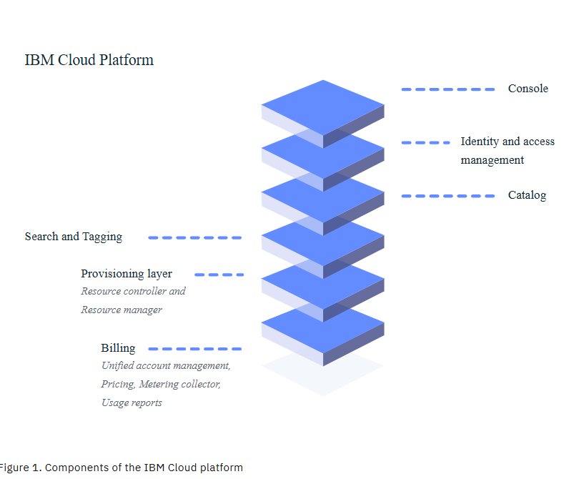

Whether you have existing code that you want to modernize and bring to the cloud or you're developing a brand new application, your developers can tap into the rapidly growing ecosystem of available services and runtime frameworks in IBM Cloud.